# Report for Ethan Lickey (2024-10-01 to 2024-10-31)

Average Bat Speed: 36.78

Average Rotational Acceleration: 3.10

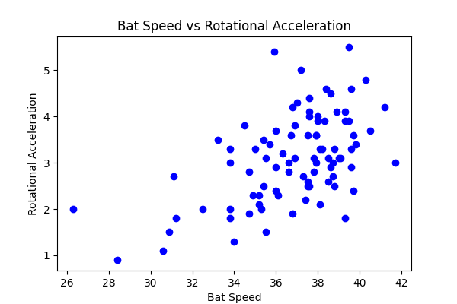

## Comments

Add comments here...